Install Zentyal as PDC (Primary Domain Controller) and Integrate Windows System – Part 1
by Matei Cezar | Published: April 7, 2014 | Last Updated: April 4, 2015
This series will be titled Preparation for the setting up and managing Zentyal as PDC (Primary Domain Controller) through Parts 1-14 and covers the following topics.
Part 1: Install Zentyal as PDC (Primary Domain Controller) and Integrate Windows System
Part 2: How to Manage Zentyal PDC (Primary Domain Controller) from Windows System
Part 3: Creating Organizational Units (OU) and Enableing GPO (Group Policy) in Zentyal PDC Server
Part 4: Setup File Sharing and Permissions for All Users in Zentyal PDC
Part 5: Integrate Ubuntu System in Zentyal PDC
Part 6: Integrate CentOS/RedHat/Fedora in Zentyal PDC
Part 7: Integrate Ubuntu 14.04 (Trusty Tahr) to Zentyal PDC
Part 8: Installing FTP Server and Mapping FTP Directories in Zentyal PDC
Part 9: Install and Configure Web Services (Apache Virtual Hosting) on Zentyal Server
Part 10: Enabling UserDir and Password Protect Web Directories on Zentyal Webserver
Part 11: Installing Pydio File Sharing Platform on Zentyal Web Server
Part 12: How to Install and Configure OpenVPN Server on Zentyal PDC
Part 13: Install and Configure Zentyal Linux 3.5 as A BDC (Backup Domain Controller)
Part 14: Joining CentOS 7 Desktop to Zentyal PDC (Primary Domain Controller)
In this tutorial will demonstrate how to use a Linux distribution, Zentyal, as a PDC ( Primary Domain Controller ) and integrate Windows based system in this Domain Controller.

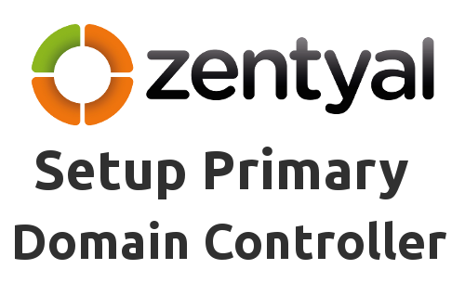
Install Zentyal as PDC

Requirements:
- Download Zentyal 3.4 Community Edition form this link http://www.zentyal.org/server/.
- A different computer that runs a Windows based system to be integrated to domain.
- The domain used is a fictional one and runs on local network only : “mydomain.com”.

Step 1: Installing Zentyal Server
1. Choose language.
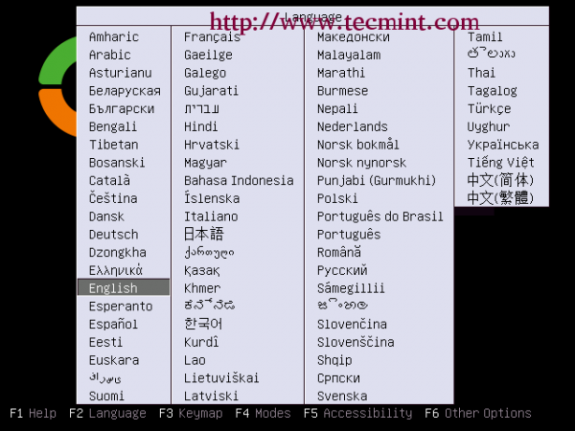
Select Language
2. Choose expert mode.
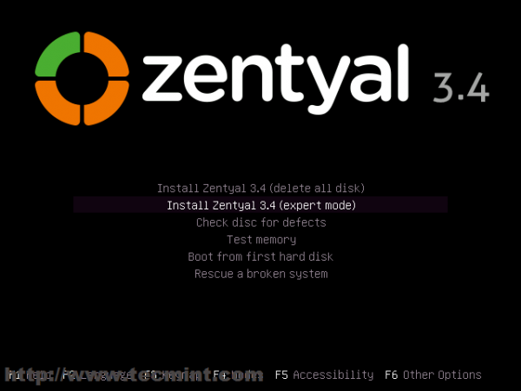
Select Language
3. Again choose your language for installation process.
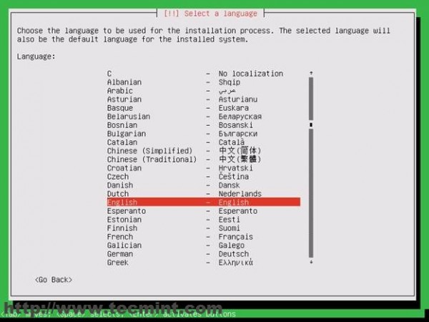
Choose Installation Language
4. Choose your location. If your country is not listed in the default options choose other , then select your continent and country: I’m in Romania so I choose Romania.
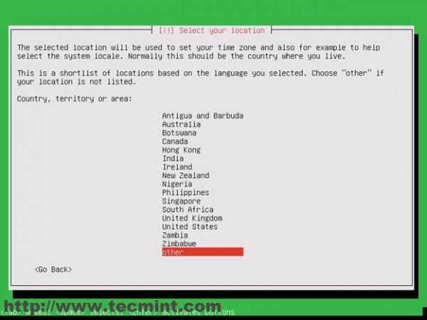
Select Country
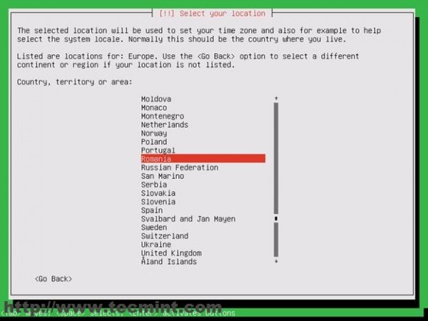
Select Location
5. Next configure your locales: I choose USA (en_US.UTF-8 ) because is a general locale.
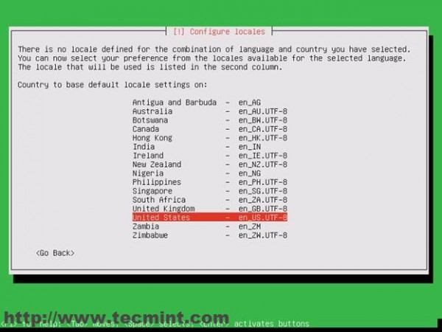
Configure Locals
6. Next select your keyboard : Again I choose Romanian keyboard.
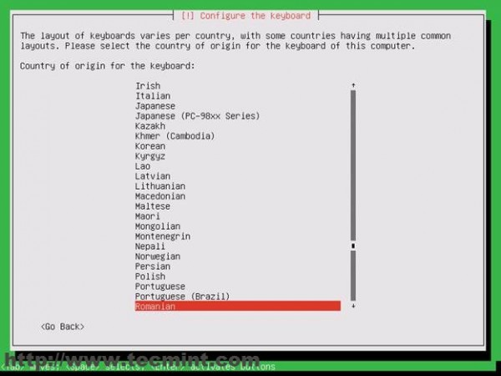
Configure Keyboard
7. Next the installer will load components needed for configuring the system.
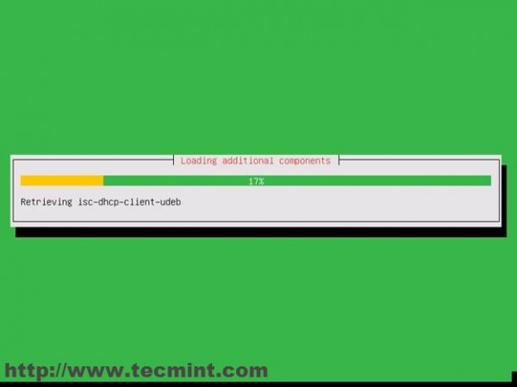
Loading Additional Components
8. The next installer stage is to set the hostname for your system. You should enter here your FQDN. This is a test server so I choose “pdc.mydomain.com” ( Be aware that “pdc” will be this server and “mydomain.com” would be your domain for Active Directory ).
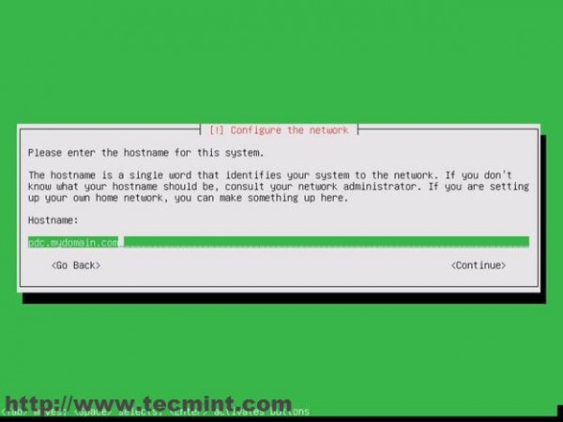
Configure Network
9. Next choose a user for system administration ( This will be the privileged user with root powers – sudo ) not the user domain controller.
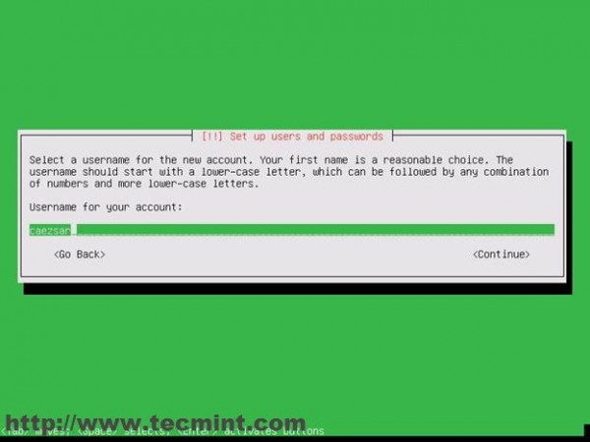
Setup User and Password
10. Next type a password for root user. Choose a strong one ( 9 characters at least upper&lower&numerical&special ). Here I choose a simple one because is a test server.
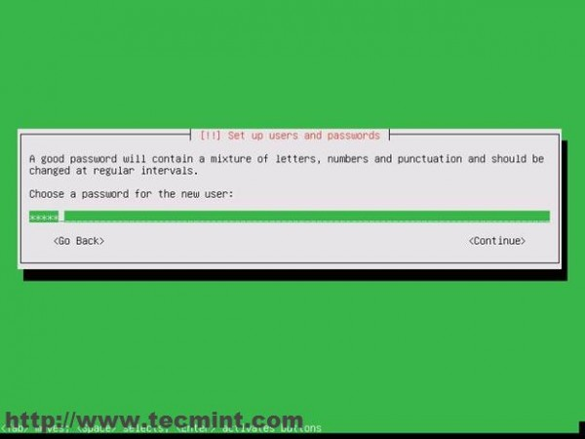
Setup Password
11. Next it will ask you to re-enter your password and if you choose a weak one the installer will warn you about this fact. So select Yes and hit enter.
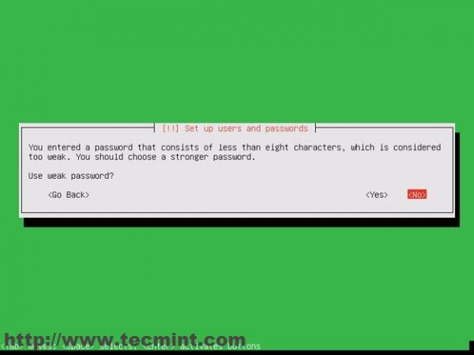
Setup Password Confirm
12. Next step is configuring your time. If your system is connected to Internet the installer will automatically detect your time zone. So press Yes if your time setting are the correct ones.
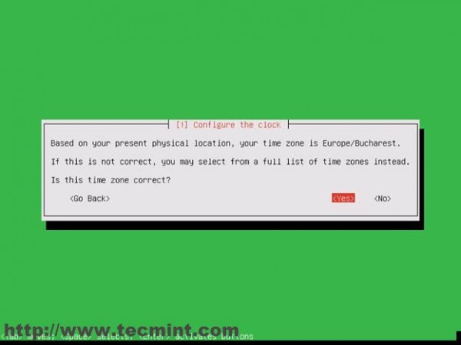
Configure Clock
13. Next screen is Partition Disks where you have four alternatives like in the images bellow. For better control over your system partition choose manual and hit Enter.
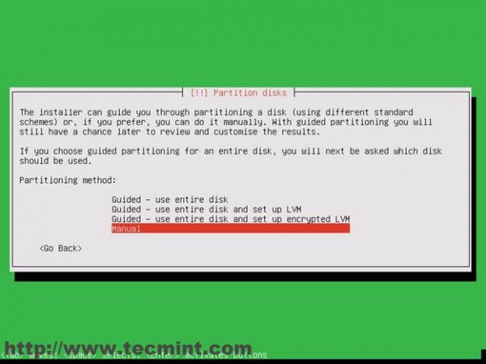
Partition Disks
14. Choose your HDD. In this setup I’m on a VMware virtual disk.
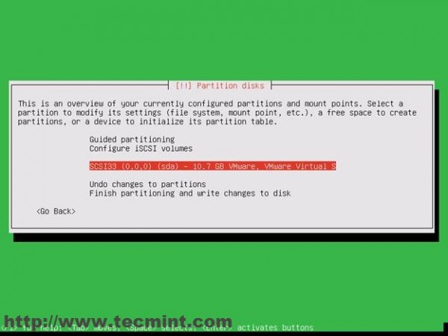
Select Partition Disks
15. Next choose Yes and hit Enter.
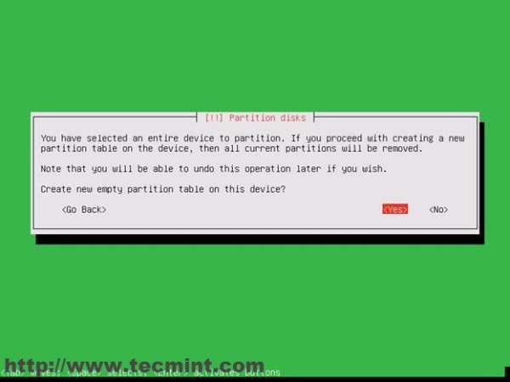
Create New Partition
16. Configuring the Hard Disk Partitions. My HDD system config is the following.
- 6 GB for / Partition ext4
- 1 GB for swap area
- 3.7 GB for /home ext4
On a real server you should allocate more space for all of partitions , even create a new one for /var. Now is time to create a partition. Follow the steps. Choose Free space.
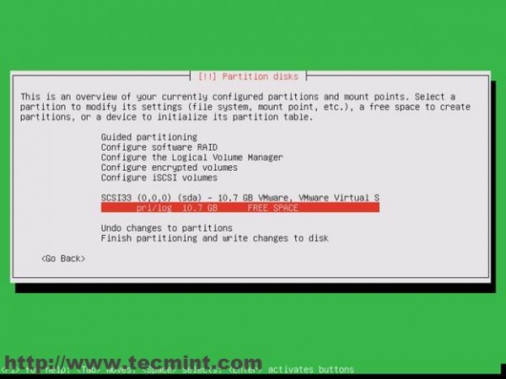
Configured Partitions
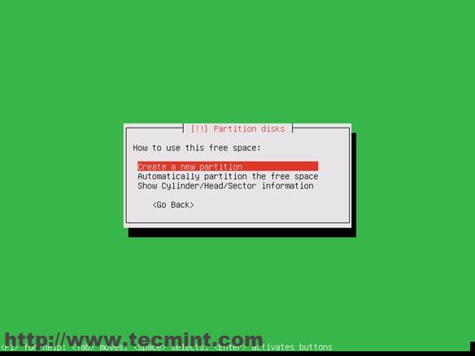
Create New Disk
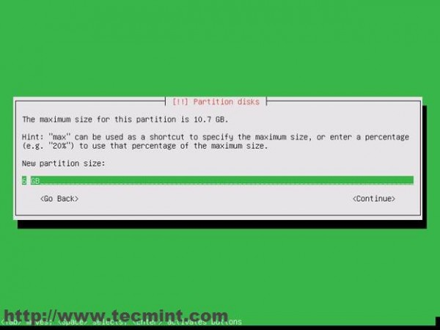
New Partition Size
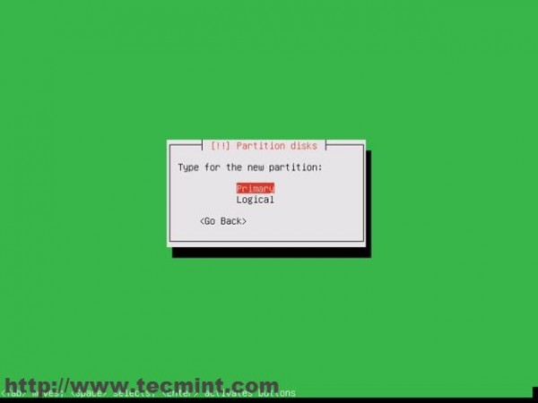
Select Partition Type
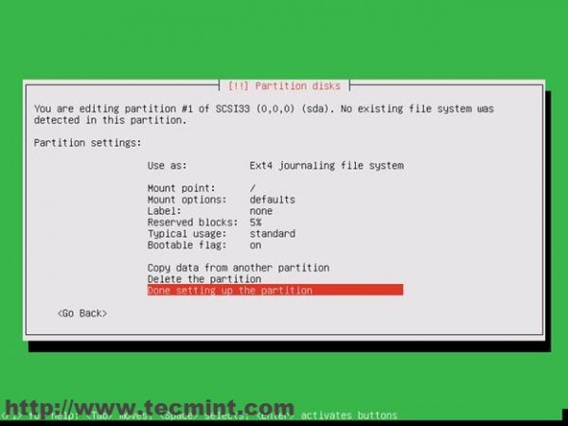
Done Setting Partitions
Repeat this steps for /home and swap partitions too. The final disk layout should look like this. On the next warn dialog choose yes and hit Enter again.
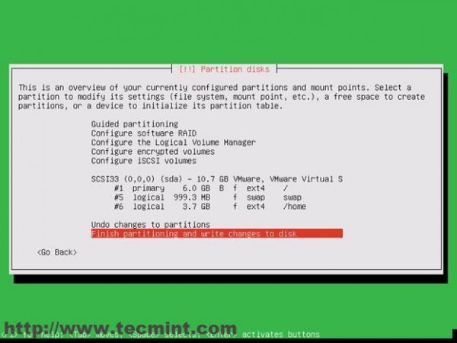
Write Changes to Disk
17. The next stage on the installer is asking if you want to setup a Graphical Environment for Zentyal. If your server has a monitor and a keyboard attached to it then you should probably choose No ( This will install a LXDE GUI ) else choose yes ( you will control your system remotely using web admin interface and ssh ).
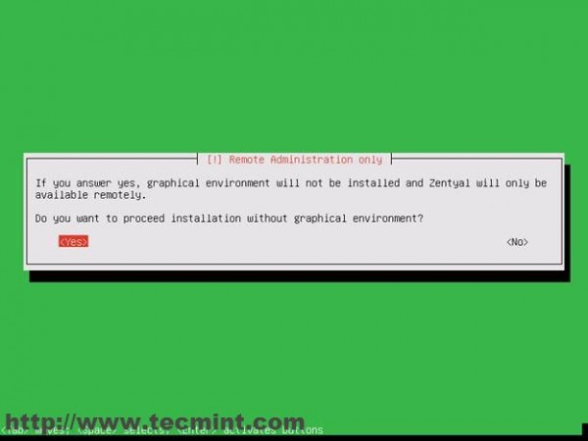
Select Installation Mode
18. Next your system starts installing.
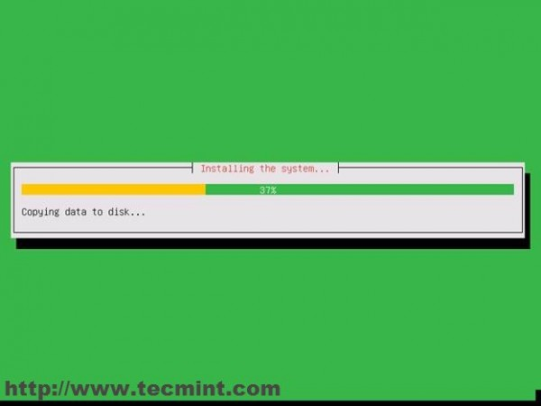
Copying data to Disk
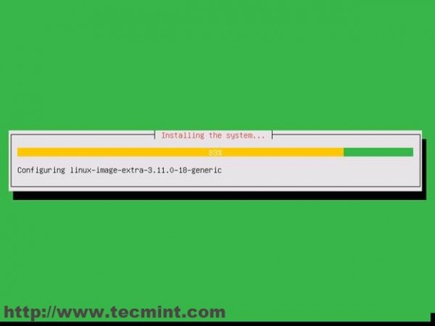
Configuring Linux Image
19. On the next dialog just hit enter ( if you are accessing internet through a proxy you should enter it now).
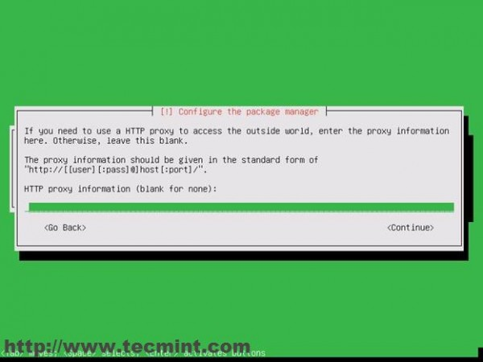
Configure Package Manager
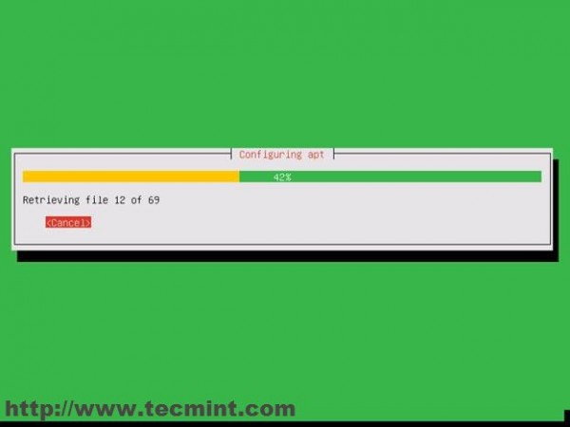
Configuring Apt
20. Choose Yes for installing Grub into MBR.
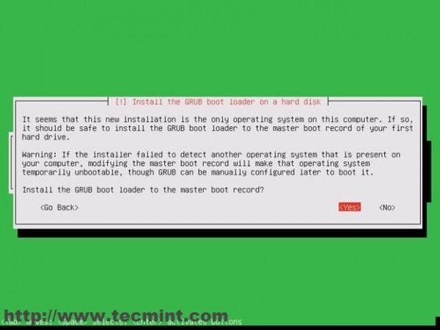
Install GRUB Boot Loader
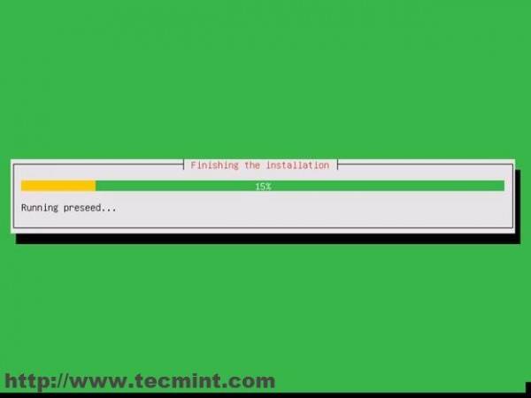
Finishing Installation
21. Next choose Yes for next warning about UTC time.
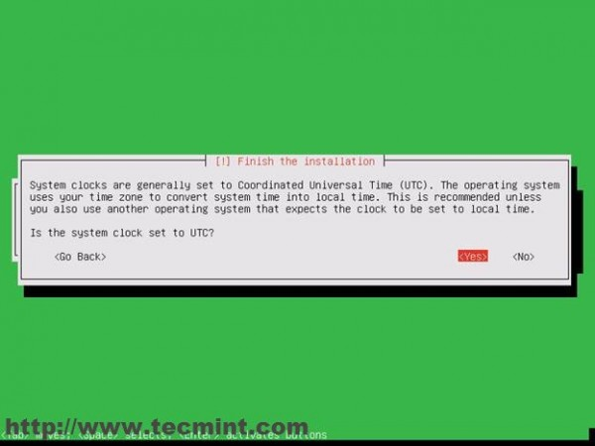
Set System Clock
22. And we reached finish line. Press enter to continue and the system will reboot.
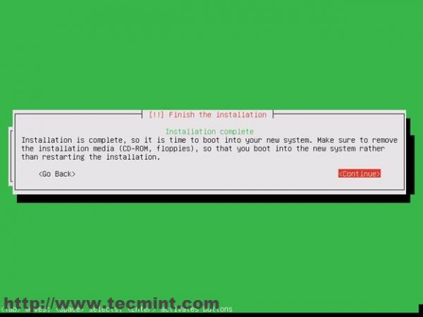
Installation is Complete
After rebooting the system will install some basic software and the it will prompt us for web IP administration.
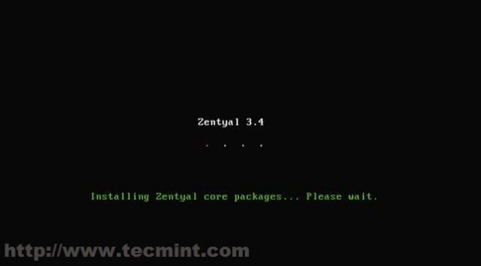
Installing Core Packages
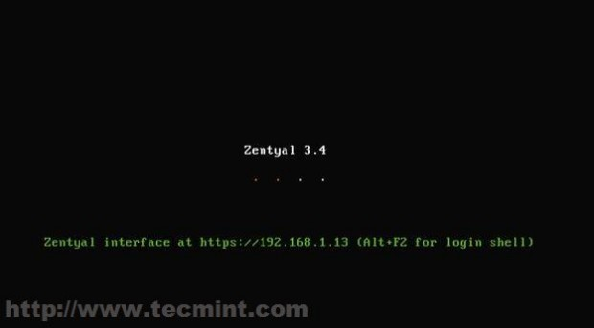
Zentyal Admin Interface

Step 2: Installing Basic Softwares for PDC
Now it’s time to go to heavy stuff …meaning accessing web remote administrating tool and installing the basic software for the server to become a complete Primary Domain Controller (PDC) with samba4.
- Next open a web browser and type the address prompted in Zentyal ( for this example the web admin address is : https://192.168.1.13 ).
- Next the web browser it will warn you about a security issue relating the certificate.
23. Choose “I Understand the Risks” , “Add exception“ and then “Confirm Security Exception” like in the screenshoots below.
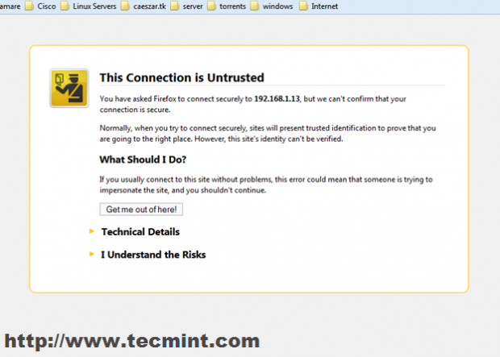
Choose HTTPS
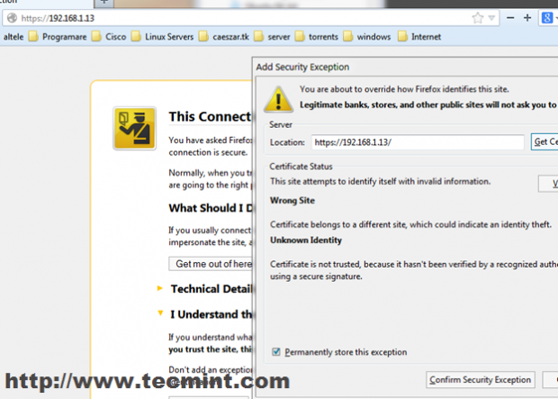
Add Security Exception
24. Then enter your user and password for admin user ( the user created on installation).
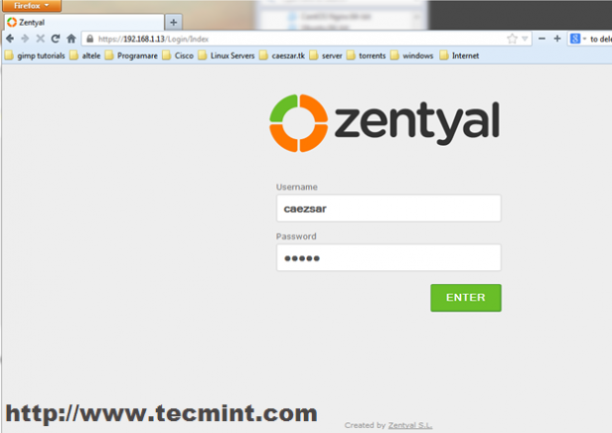
Zentyal Admin Login
25. We are now presented with the Zentyal Web Administration and it’s time to choose and install software for our PDC.
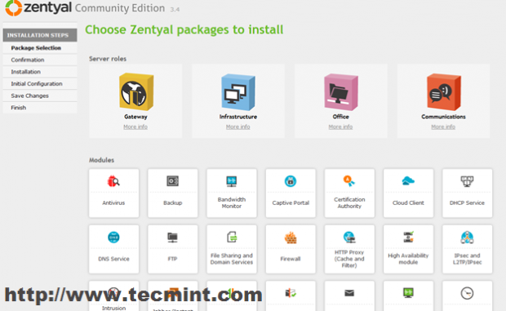
Select Packages to Install
26. Choose the following packages (modules) for the server to become a Primary Domain Controller.
- DNS Service
- File Sharing and Domain Services
- Firewall
- Network Configuration
- Printer Sharing Service
- Users and Computers
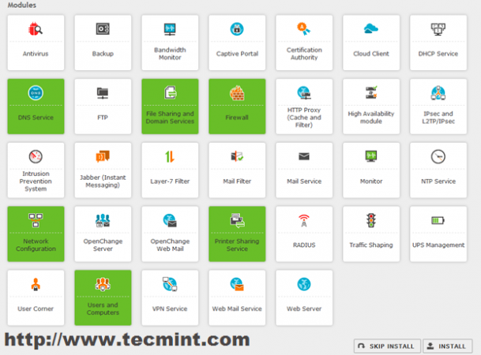
Package Selection
27. Confirm your modules installation.
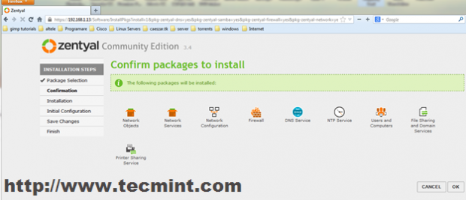
Confirm Package to Install
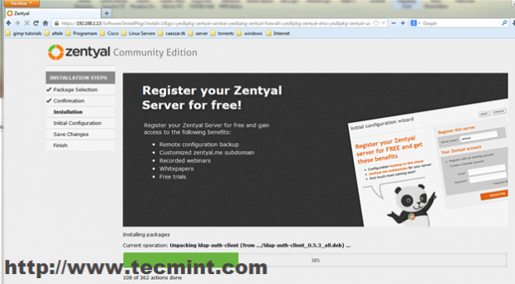
Installing Packages
28. Next configure your Network Interface as Internal.
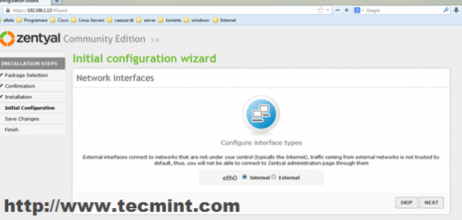
Configure Network
29. Next choose Static Method and enter your static IP server address ( this will be the pdc address) , netmask , gateway and DNS servers.
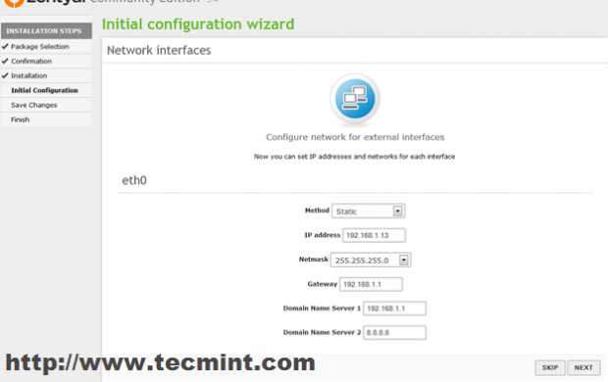
Enter Network Details
30. Choose Standalone server and enter your domain name ( not FQDN) and hit Finish.
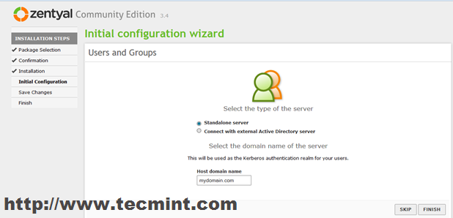
Select Server Type
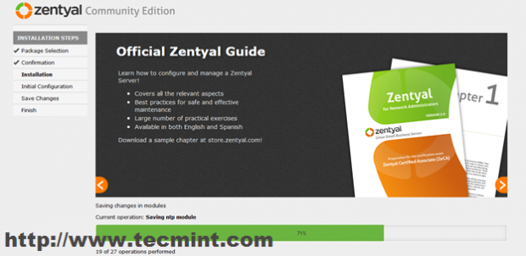
Saving Changes
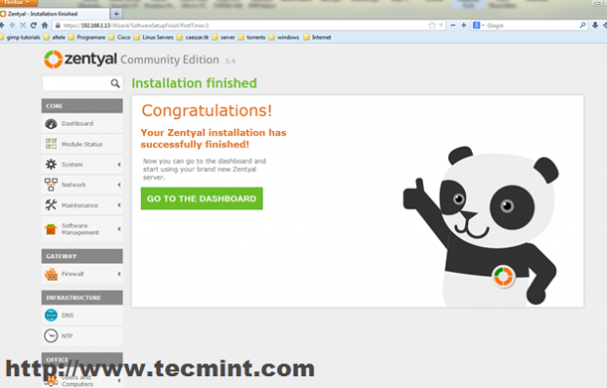
Installation Finished
Now the software for this server to become a PDC is installed and ready to be used.
31. Now you should go to DNS Module and make sure that your domain is listed in the Domains tab.
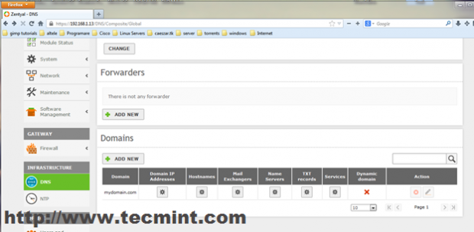
Add Domain in DNS
32. Then go to Users and Computers Module , select Manage and add a user with Administrator Privileges for Active Directory. Select Users , Click on “+” button bellow and enter your credentials.
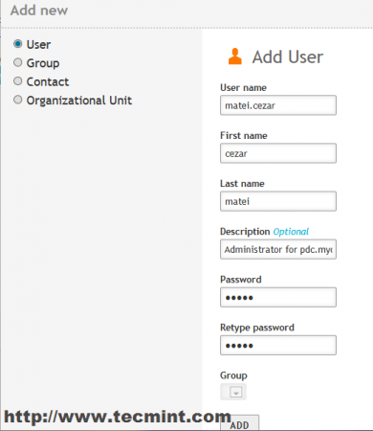
Add User
33. Then select the user you just created an on the right side under User Groups field select Domain Admins and hit the “+” button so it should look like bellow screenshots.
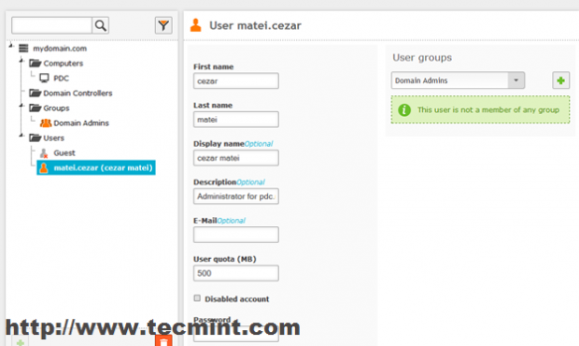
Select Domain Admins
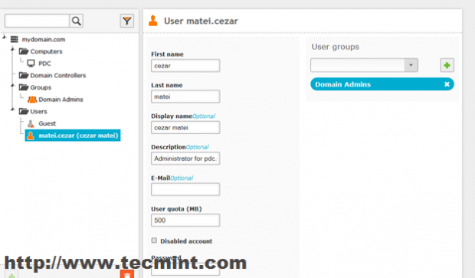
Added Domain Admins
34. Now go to Domain Module , select Settings , choose a description for your server, select “Enable roaming profiles” and hit Change button.
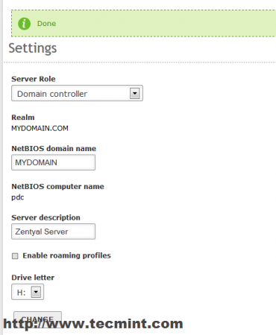
Enable Roaming Profiles
35. Now go top right and click on Save Changes for the system to apply your new settings and Click Save.
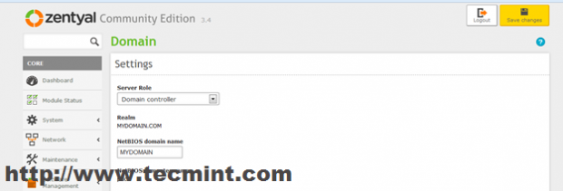
Save Domain Settings
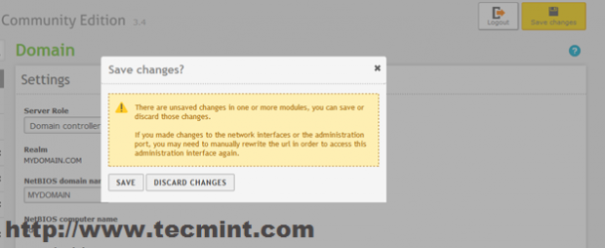
Save Changes
That’s it for now on the pdc server minimal configuration to become a Primary Domain Controller.

Step 3: Integrating a Windows System in PDC
It’s time to integrate a Windows based system ( In this example a Windows 7 system) in the “mydomian.com” domain.
36. First let’s setup network configuration for the system to be able to access the new domain. Go to Start -> Control Panel -> Network and Internet -> Network and Sharing Center -> View Network Status and Tasks -> Local Area Connection.
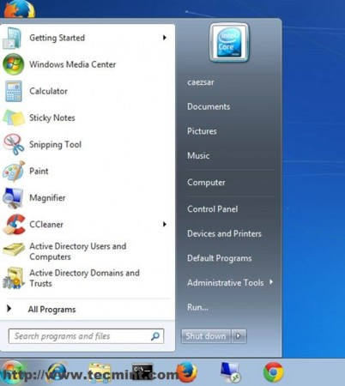
Setup Network Configuration
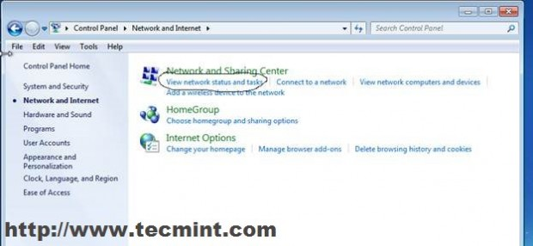
Network Sharing Center
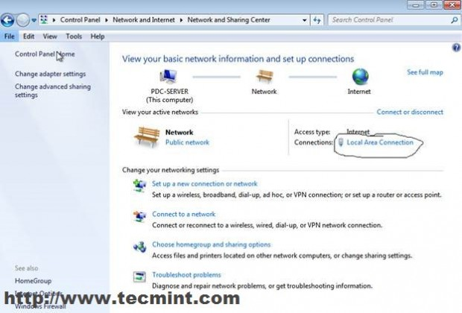
Local Area Connection
37. On Local Area Connection select Properties -> IPv4 -> and enter your static IP, netmask, Gateway and DNS like in the screenshoots bellow.
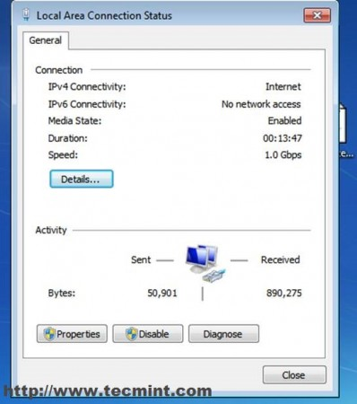
Enter IP Details
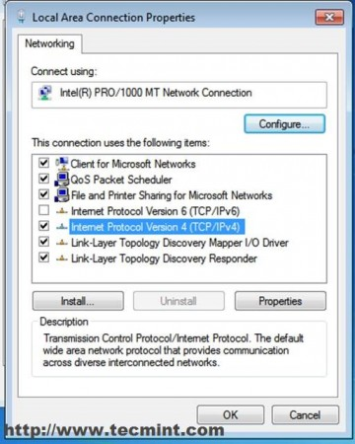
Local Network Properties
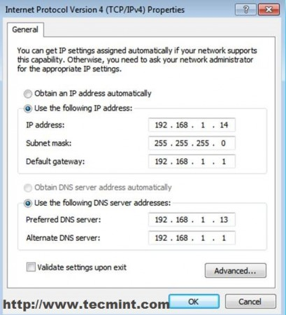
Enter Network Details
38. To be sure that everything is OK try first pinging your pdc server address and then ping domain name.
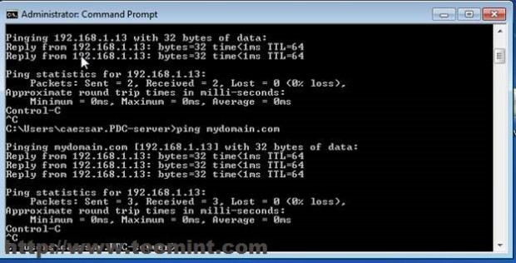
Ping Domain to Confirm
39. We now reach the end of this tutorial. Let’s finish the configuration by adding Windows 7 to the mydomain.com domain name. Click “Computer” -> System Properties -> Advanced System Settings -> Computer Name.
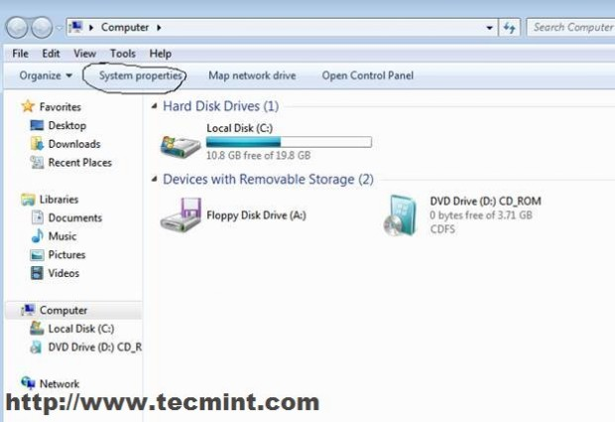
Adding Windows Domain
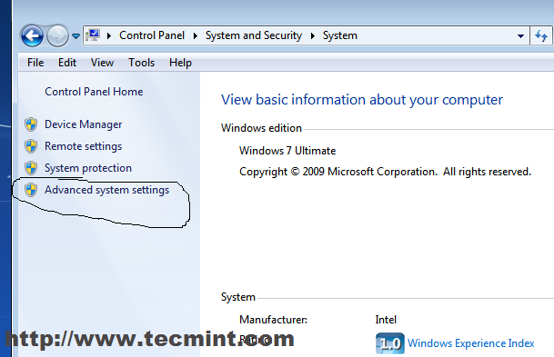
System Settings
40. Enter your computer name in Computer Name field domain in Member of Domain.
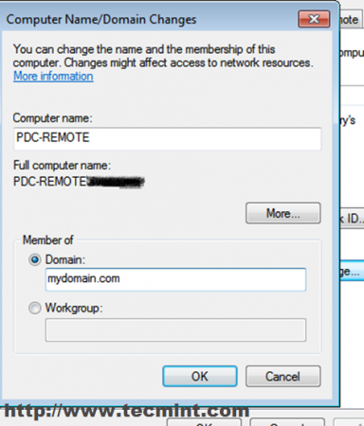
Enter Domain Name
41. On the next prompt enter username and password for the Administrator User of your domain ( the user created in Users and Computer through Zentyal Web Interface).
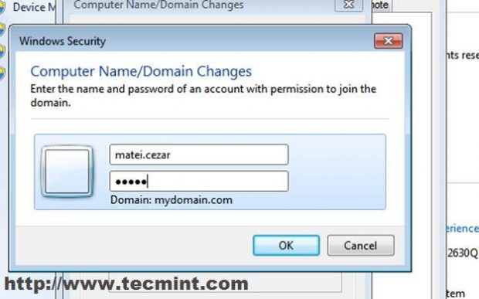
Enter Domain User and Pass
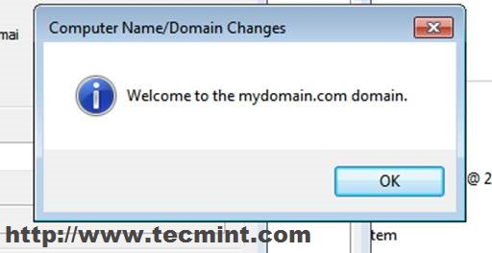
Welcome to Domain
42. Reboot the computer to apply the setting and logon to your new domain.
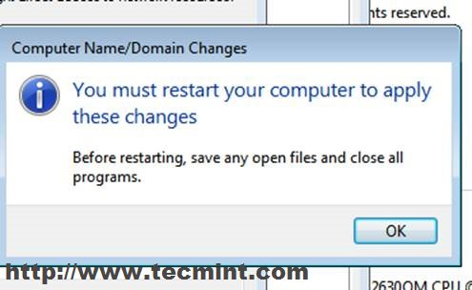
Restart Computer
43. After reboot on logon enter domain and administrator username.
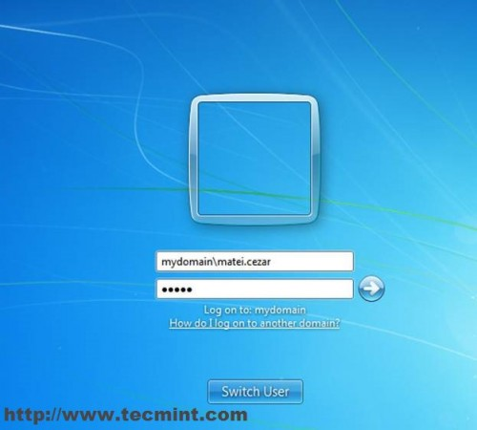
Enter Domain Admin Details
44. Navigate again to https://192.168.1.13 and check if the Computer has been added to Users and Computers.
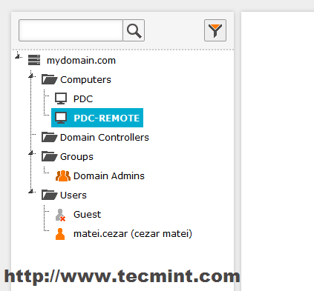
Confirm PDC Status
Congratulations! You now have a full domain service and you can easily add other windows based system into your new domain .
Next tutorial will be on how to access your pdc server remotely from Windows based systems, Create new Users and Groups, Create a Share and setup Group Policy for this domain users and computers.

